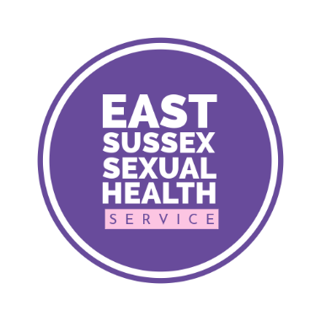

Specialist Sexual Health

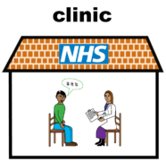 | We can help you with contraception, sexual health and HIV
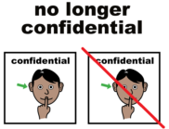  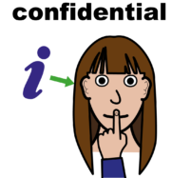 | We don’t tell anyone about your visit. We won’t tell your parents, support workers or doctor.  but  we may have to tell someone if we are concerned for your safety
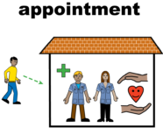  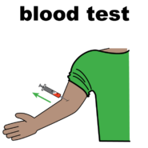  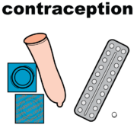 | We offer:  - Telephone and in person appointments  - HIV testing and treatment  - Contraception, condoms and emergency contraception  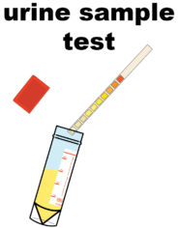  - Pregnancy testing
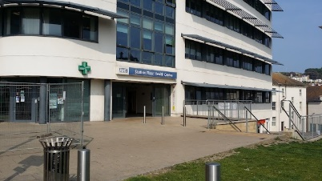  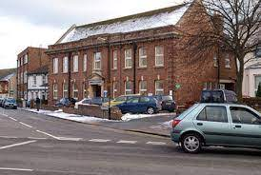 | We have two clinics:  Station Plaza in Hastings  and  Avenue House in Eastbourne
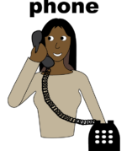 | Call us on 0300 013 2050 to book an appointment or ask any questions
Easy read leaflet s https://www.easyhealth.org.uk/

